Dlamini Christian (217036408)

Dzitiro Esther (216023315)

Ntobela Sipho (217067552)

Zamisa Nkosinathi (216059098)

**I. The ELECTRE Algorithm**

1. **Normalize the Decision Matrix**

The normalized decision matrix *R* is a 50×11 matrix. It was derived from the decision matrix *D*

where element *dij* of the decision matrix is divided by the square root of the sum of all the elements in the *i*th row squared, resulting in an element of the matrix *R*. The resulting normalized decision matrix output is shown in Fig. 1.

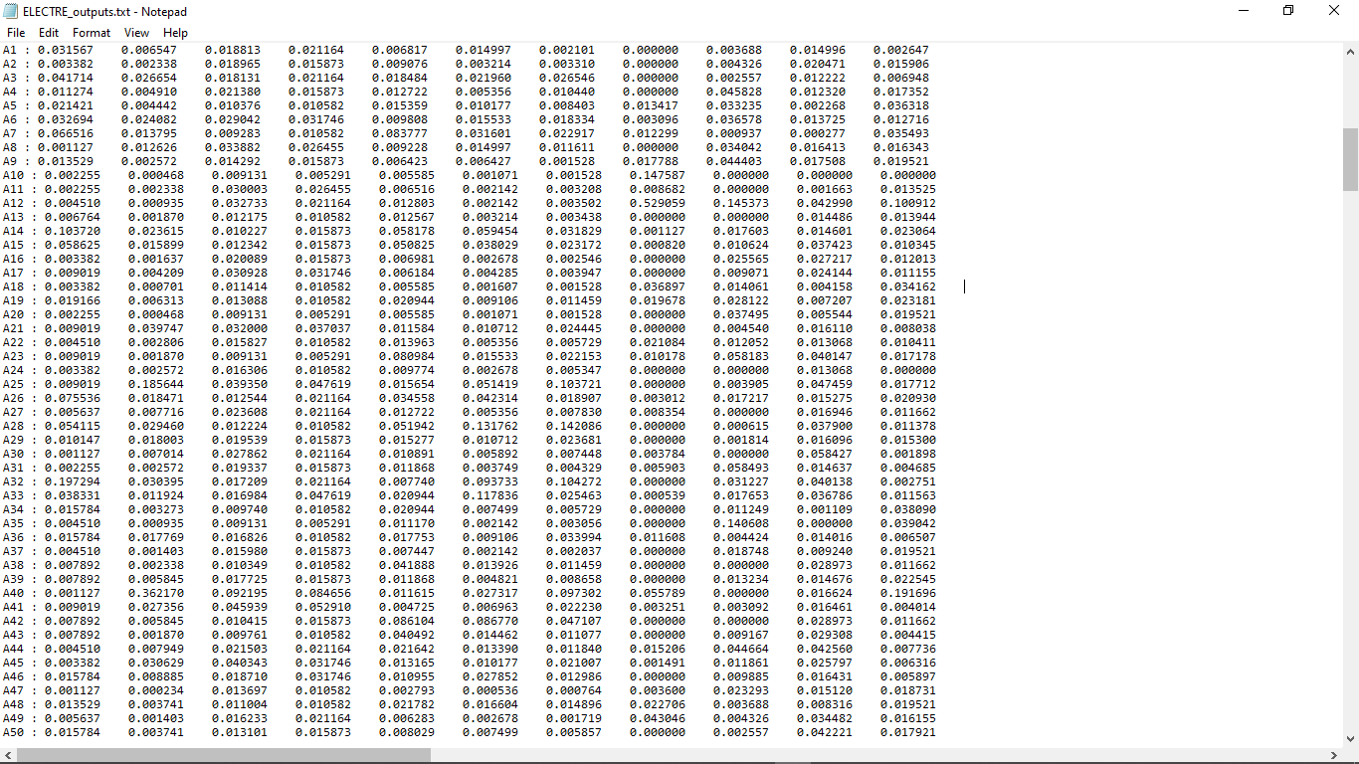

Figure 1 The output of normalized Decision matrix.

2. **Construct the Weighted Normalized Matrix**

The weighted normalized matrix *V* is a 50×11 matrix. It was derived from the normalized matrix *R* through by multiplying the elements of *R* with their respective weight *w*j in column *j.* The weights were obtained using the entropy method, and the output is shown in Fig. 2. The calculated matrix is shown in Fig. 3.

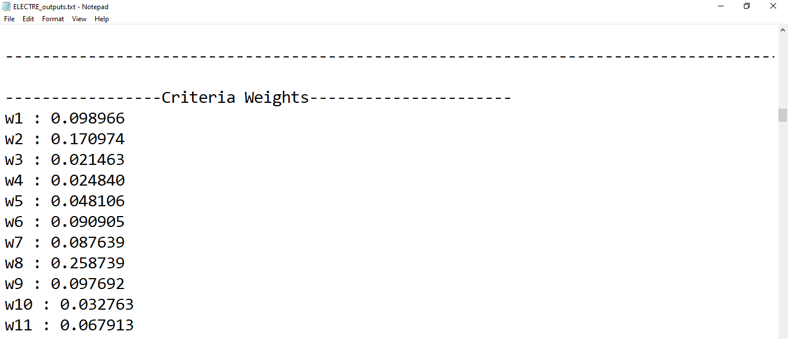

Figure 2 The criteria weights output using the entropy method.

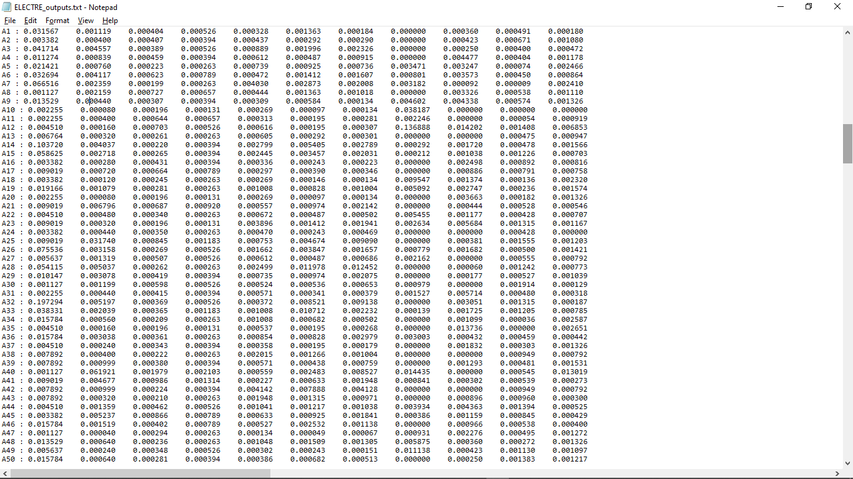

Figure 3 The output of the Normalized weighted matrix.

3. **Compute the Concordance and Discordance Matrices using Sets**

**3.1 Concordance matrix**

The concordance matrix *C* is a 50×50 matrix. This matrix was obtained using the concordance set, weights *wj,* and weighted normalized matrix *V*. For each Alternative *Ar* against *As* a discordance set was obtained. The set had all the *V* elements at *j* columns when *Ar* was more performing than *As*. The elements of *C* were thus the sum of all the criteria weights *wj*, which are in the columns *j* of concordance set. The values for the elements when *r=s* defaulted to zero as these were not defined. Thus, *Crs* is the concordance index of *Ar* compared to *As* when *r≠s* The concordance matrix output obtained is shown in Fig. 4a-4d.

**3.2 Discordance matrix**

Similar to the concordance matrix, the discordance matrix *D* is a 50×50 matrix. The matrix was derived from the weighted normalized matrix *V* using the discordance set. For each Alternative *Ar* against *As* a discordance set was obtained. This set was obtained by comparing the *V* elements when *Ar* was less performing than *As*. Then for each of the columns *j* in the discordance set, the absolute difference |Vsj−Vrj| in the *V* elements was computed, with the maximum absolute difference being chosen. Another absolute difference |Vsj−Vrj| was obtained for all columns *j* however, this time, those elements that were excluded in the discordance set were now included.

The maximum of these differences was obtained. The concordance maximum abs difference was then divided by the second absolute maximum to get the value of the element of *D.* The comparison skipped the elements when *r=s* as this was a comparison of the same alternative. Thus the resulting matrix had a diagonal with elements of zeros. The output of the calculated matrix is shown in Fig 5a-5d.

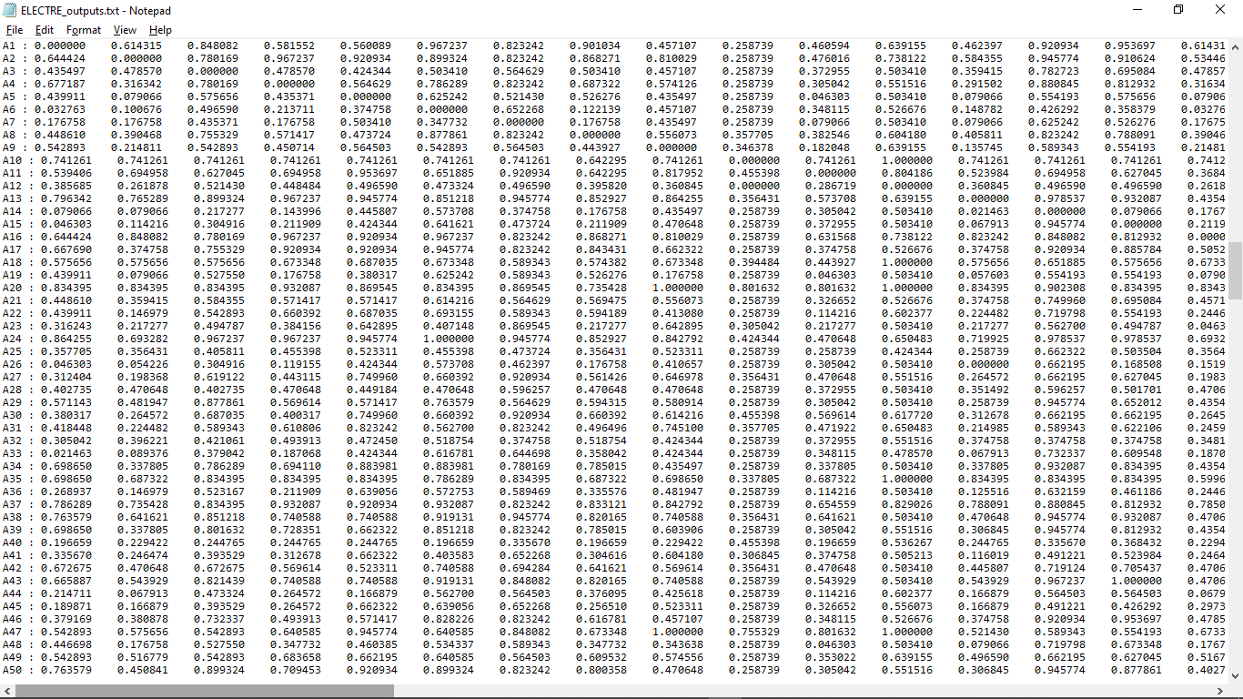

Figure 4a: The output of the normalized matrix from column 1-15.

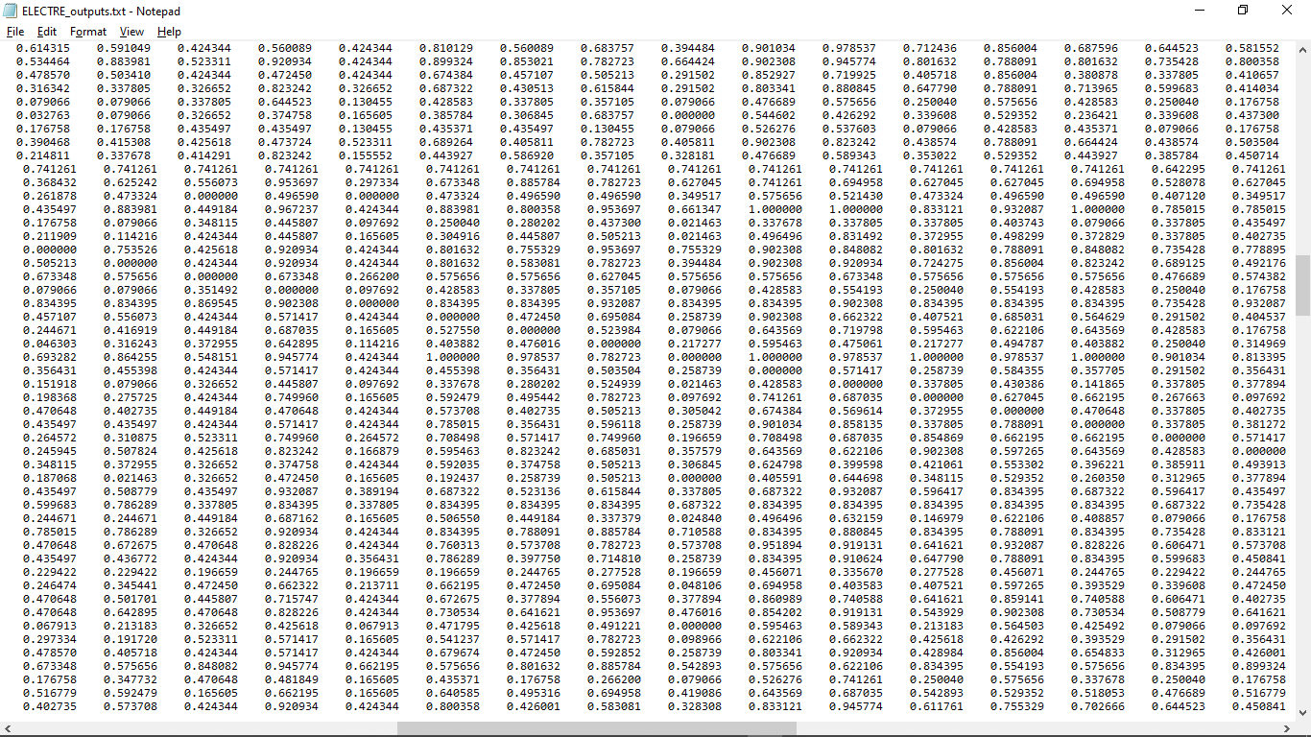

Figure 4b The output of the normalized matrix from column 16-30

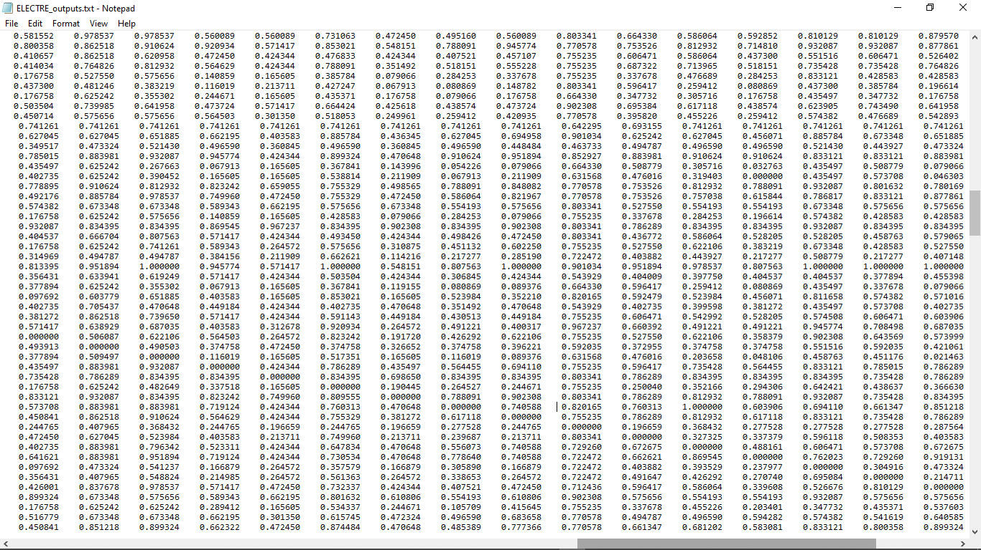

Figure 4c The output of the normalized matrix from column 31-45

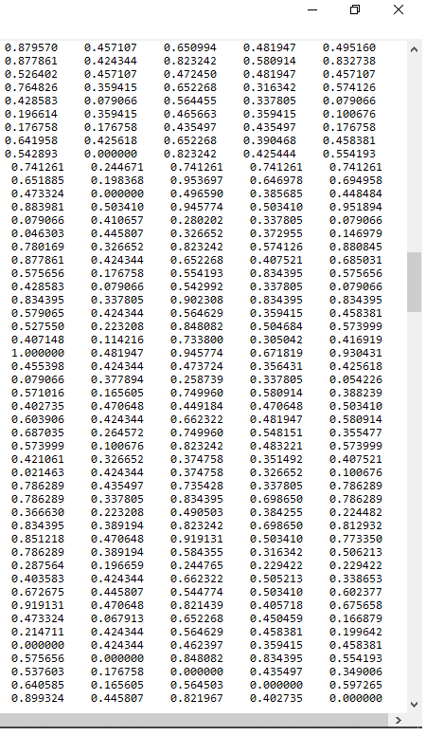

Figure 4d The output of the normalized matrix from column 31-45

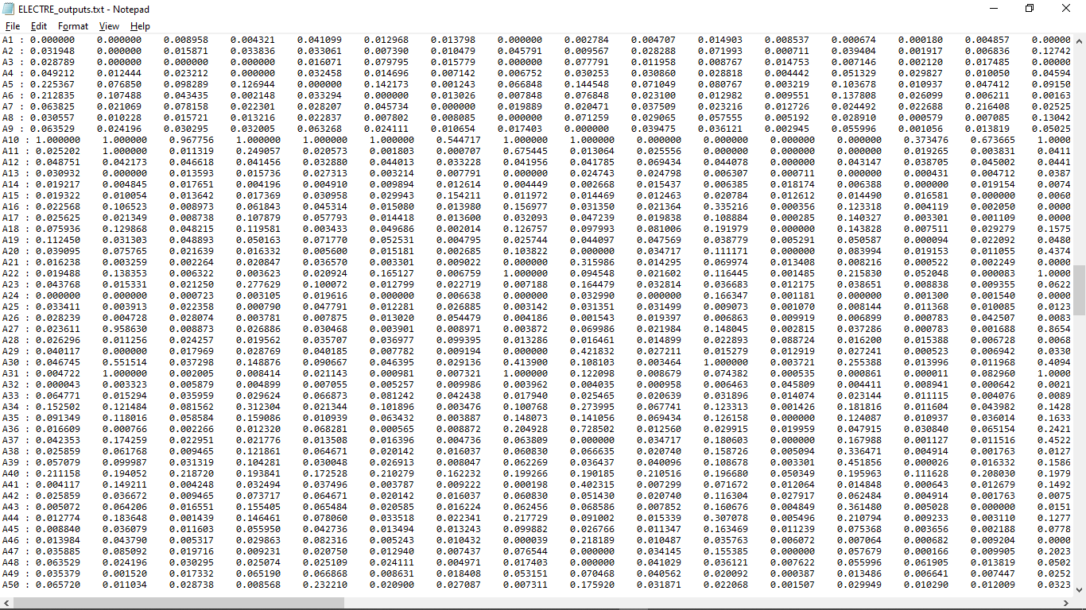

Figure 5a The output of the discordance matrix from column 1-15.

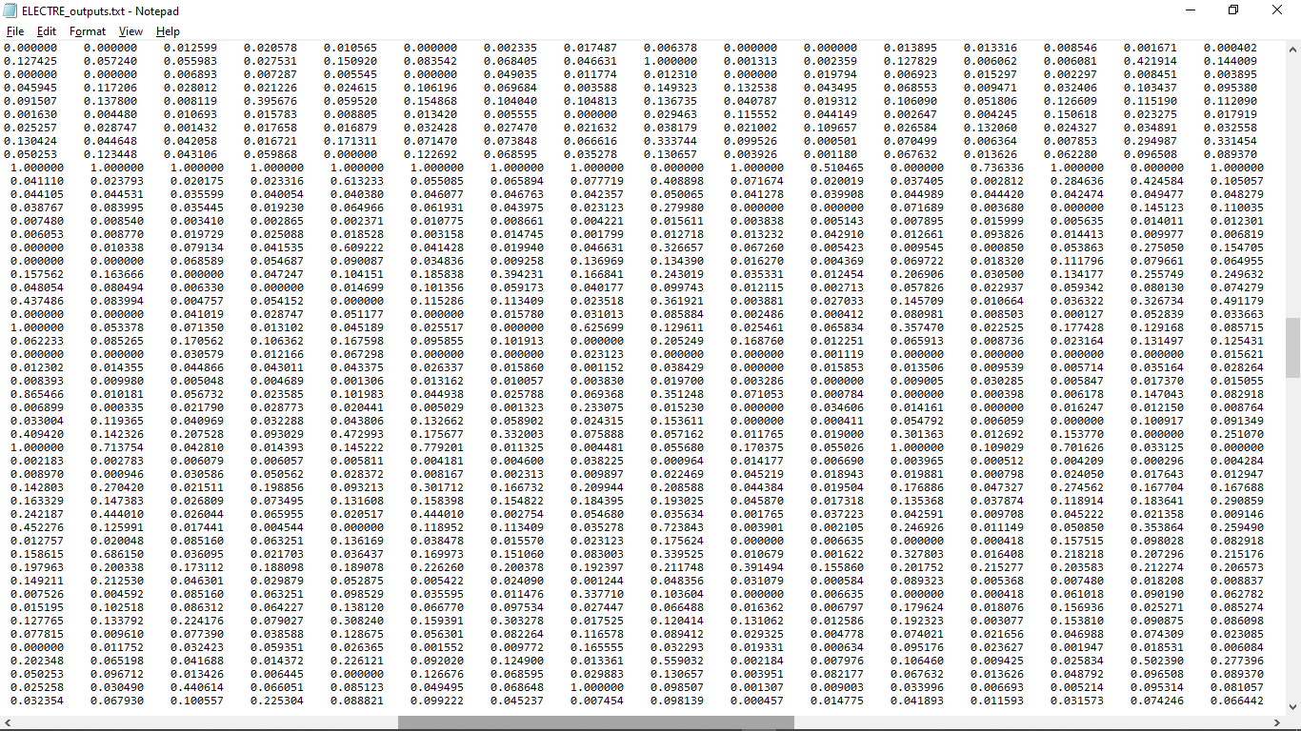

Figure 5b The output of the discordance matrix from column 16-31.

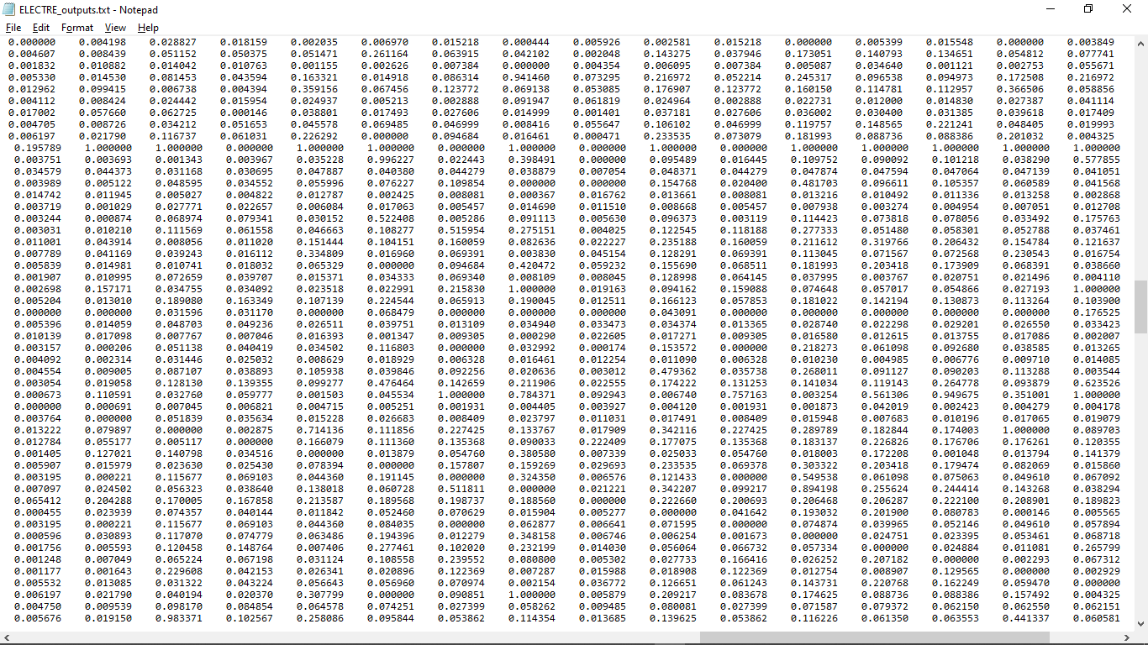

Figure 5c The output of the discordance matrix from column 32-47.

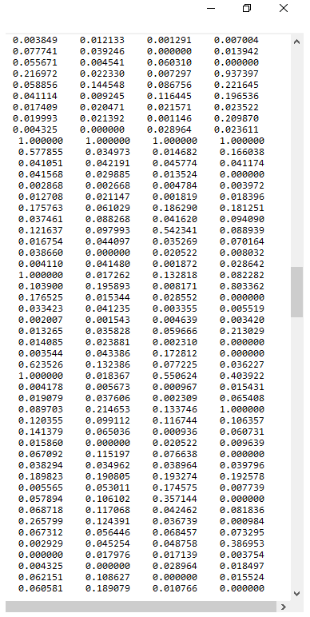

Figure 5d The output of the discordance matrix from column 48-50

4. **Compute the Concordance and Discordance Dominance Matrices**

4.1 **Concordance Dominance Matrix**

The concordance dominance matrix *CD* is a 50×50 matrix. It was derived from the concordance matrix *D* and threshold. The threshold was calculated by summing all the 2500 elements of the concordance matrix and dividing by the value 2450 (*M(M-1), M = 50*). Then for each element of the matrix, if the value is less than the threshold, an entry of zero will be the element of *CD* else; the element will be a one. The elements of the *CD* matrix were thus either one or zero. The concordance dominance matrix output is shown in Fig 6.

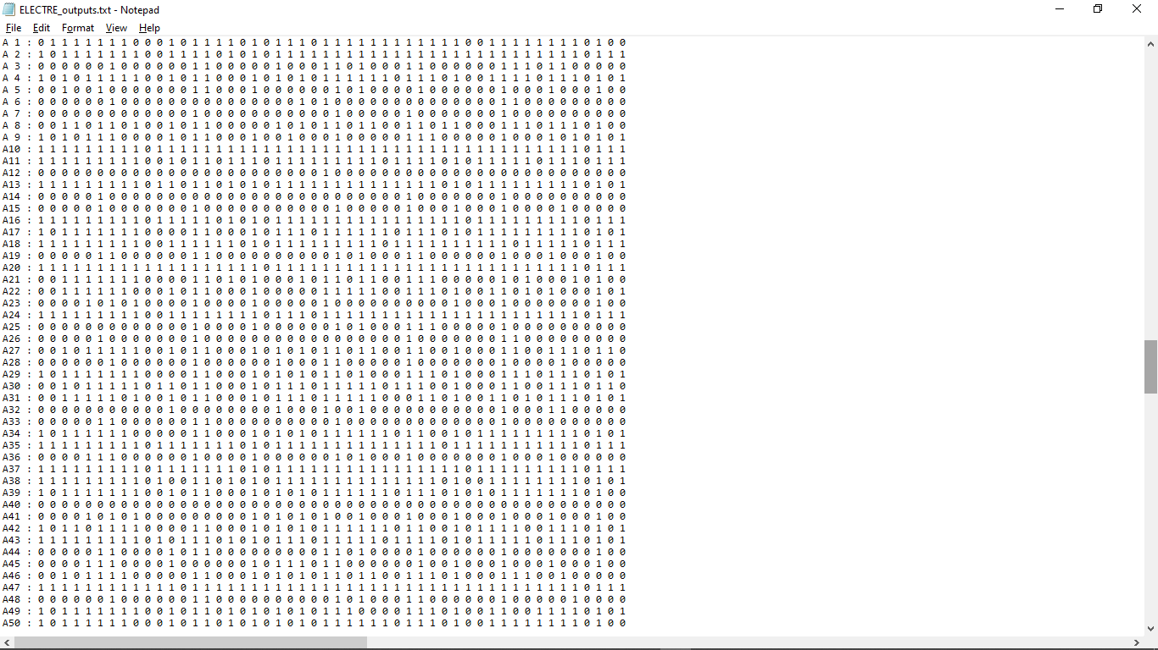

Figure 6 The output of the concordance dominance matrix.

4.2 **Discordance Dominance Matrix**

A similar procedure to the concordance dominance matrix is utilized. However, the discordance dominance matrix *DD* used the discordance matrix *D* to find the threshold and calculate the elements. The output of the calculation for the discordance dominance matrix is shown in Fig 7.

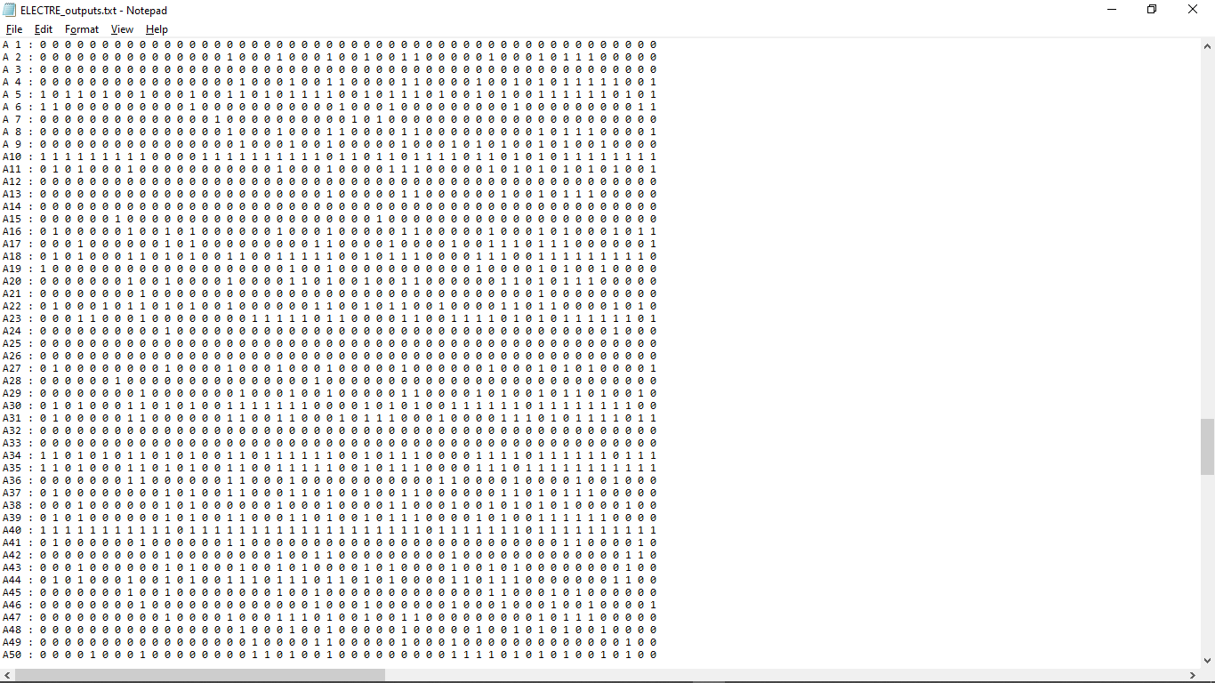

Figure 7 The output of the discordance dominance matrix.

5. **Compute the Aggregate Dominance Matrix**

The aggregate dominance matrix *AD* is a 50×50 matrix. It was obtained by multiplying each element *cdsr* of the concordance dominance matrix with the element *ddrs* of the discordance dominance matrix. The *r* and *s* indices are flipped in the *cd* elements. Thus this is the element of the transpose of the concordance dominance matrix. The aggregate matrix is also composed of elements with values of either one or zero. The output of this calculation of the matrix is shown in Fig. 8.

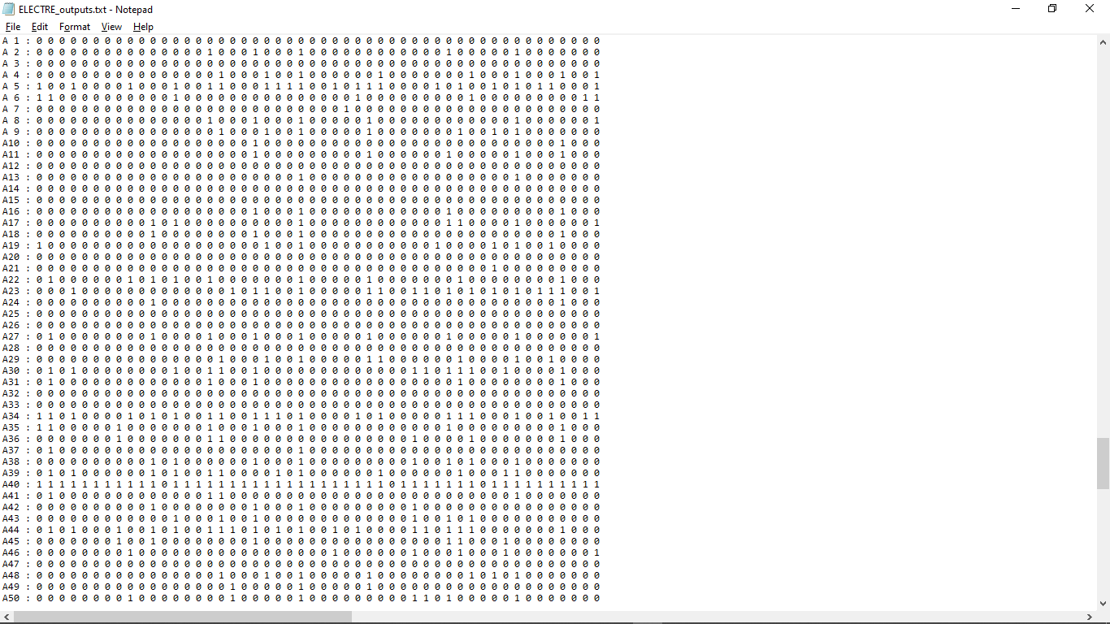

Figure 8 The output of the aggregate dominance matrix.

6. **Rank Alternatives**

A list of scores for the 50 alternatives/ontologies was calculated from the aggregate dominance matrix. The score *Sk* for each alternative *Ak* was obtained by summing all the elements in the columns *i* at the row *k* of the alternative, and then this sum was subtracted from the sum of all the elements of the rows *j* at the column *k* of the alternative. The list of scores for the alternatives is shown in Fig. 9, and the ranked list in ascending order is shown in Fig. 10.

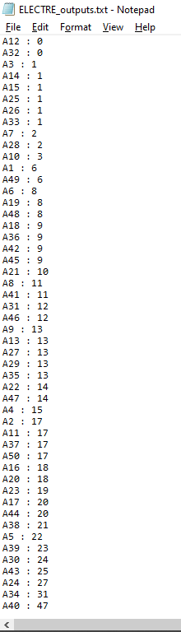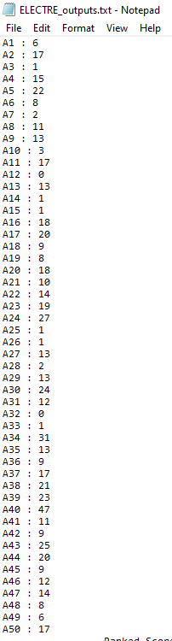

Figure 10 The output of the ranked scores of the alternatives.

Figure 9The output of the scores of the alternatives.

**II. The TOPSIS Algorithm**

1. **Normalize the Decision Matrix**

The normalized decision matrix *R* is a 50×11 matrix. It was derived from the decision matrix *D*

where element *dij* of the decision matrix is divided by the square-root of the sum of all the elements in the *i*th row squared, resulting in an element of the matrix *R*. The resulting normalized decision matrix is shown in Fig. 11.

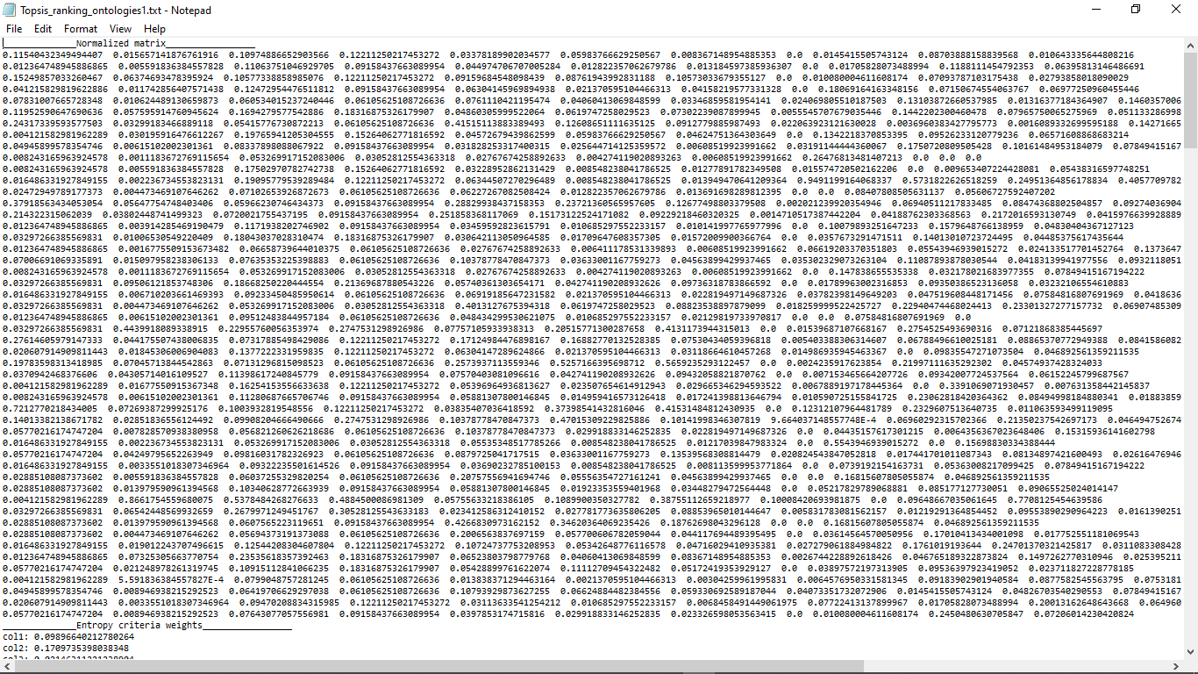

Figure 11 The output of normalized Decision matrix.

2. **Construct the Weighted Normalized Matrix**

The weighted normalized matrix *V* is a 50×11 matrix. It was derived from the normalized matrix *R* through by multiplying the elements of *R* with their respective weight *w*j in the column *j.* The weights were obtained using the entropy method. The calculated matrix is shown in Fig. 12.

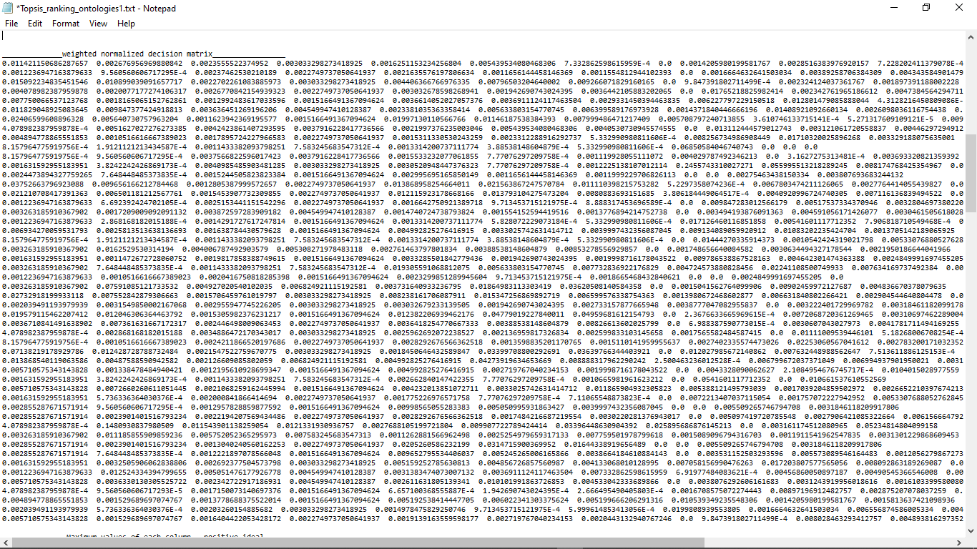

Figure 12 The output of the Normalized weighted matrix.

3. **Build the Positive and Negative Ideal Solutions**

The positive ideal solution *A+* was obtained by finding the maximum value of each column in the weighted normalized matrix *V*. The *A+* was thus a list of 11 values, which are each the maximum in their respective column. For example, the maximum value of the first column of the matrix *V* is 0.02406599608896328, as shown in Fig. 13.

Similarly, the negative ideal solution *A-* was obtained by finding the minimum value of each column in the weighted normalized matrix *V*. It also had 11 values of which all were minimums in their respective columns. For example, the minimum value of the 2nd column of the matrix *V* is 1.9121121213434587×10-4, as shown in Fig. 14.

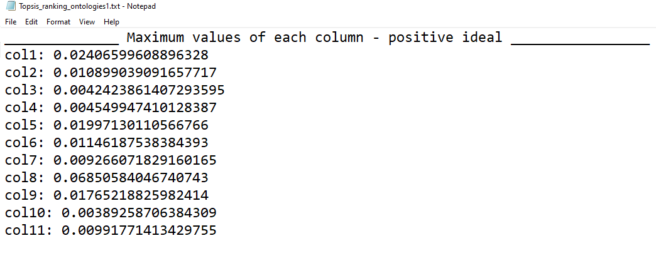

Figure 13 The output of the positive ideal solutions.

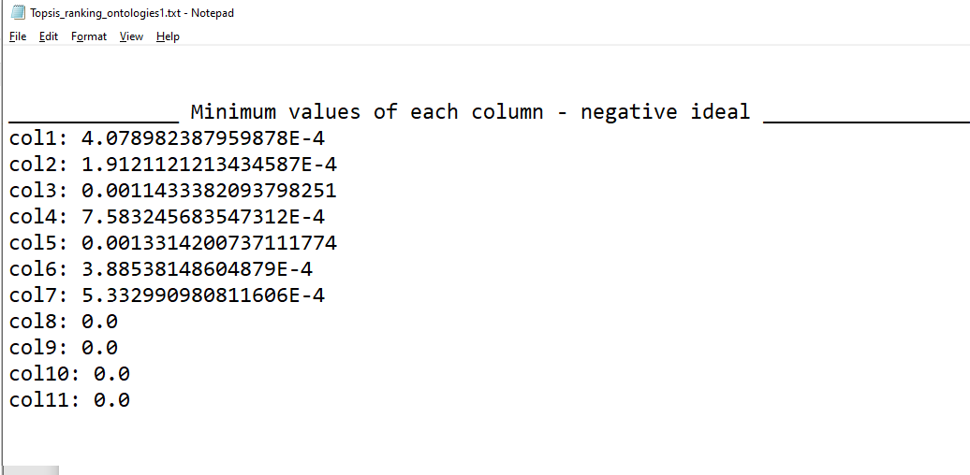

Figure 14 The output of the negative ideal solutions.

4. **Calculate the Distances from Positive and Negative Ideal Solutions**

The distances *di+* from the positive ideal solutions was then calculated. This is shown as a list of 50 values corresponding to distances for each alternative in Fig. 15. This was calculated by finding the sum of the square of the distance between the *Vij* and *Vj* elements at each row *i* of the weighted normalized matrix *V*. The *Vij* is an element of *V* and the *Vj* is an element of *A+*.

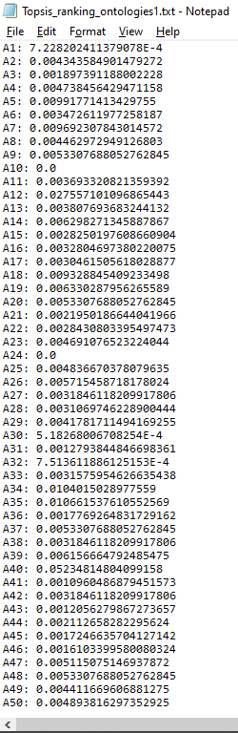Similar to finding *di+*, the distances *di-* from the negative solutions were calculated. However, the *Vj* element belongs to *A-*. The list obtained is shown in Fig. 16 as a list of 50 values corresponding to the alternatives.

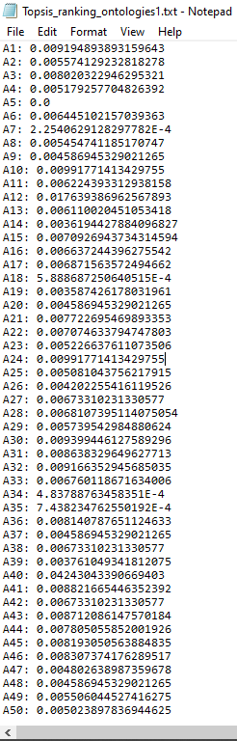

Figure 16 The output of the negative ideal solutions.

Figure 15 The output of the distance of positive solutions.

5. **Calculate the Relative Closeness of Alternatives to Ideal Solutions**

The relative closeness *Ci* was then calculated from the positive and negative distances. Each negative distance *di-* was divided by the sum *di-*+ *di+* resulting in a value of *Ci*. Fig. 17 is the output of the calculation of the relative closeness, which is a list of 50 values corresponding to each alternative. This is the score of each alternative.

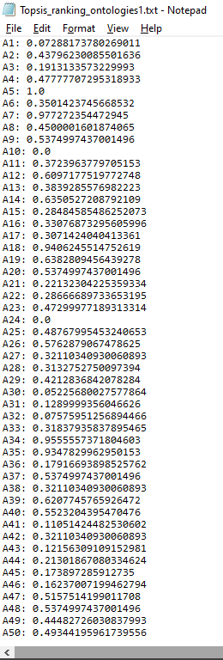

Figure 17 The output of the relative closeness.

6. **Ranking of Alternative**

The scores were ranked in ascending, resulting in the output in Fig. 18.

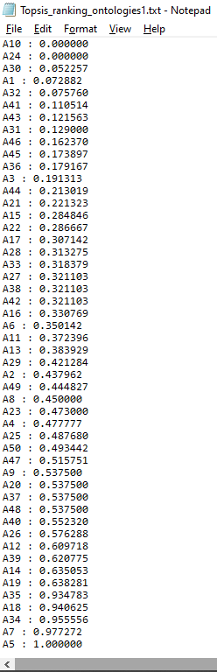

Figure 18 The output of the ranked relative closeness